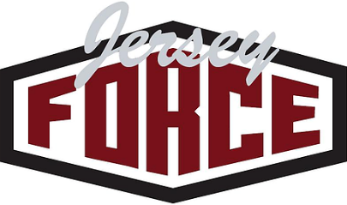
JERSEY FORCE 12U REED

4/7- 4/8 Garden State Tip Off Classic Madison
4/21- 4/22 I95 Spring Showdown Sportika
5/5-5/6 Jersey Force Classic Ocean
5/19- 5/20 Hilltopper Heat Classic Bloomfield
5/26-5/27 Basketball Spotlight MDC HG Headquarters
6/2- 6/3 Summer Mayhem Classic Spooky Nook
6/8-6/10 Belmar Hoop Splash Belmar
6/23- 6/24 Game on Hoops East Coast Challenge Sportika

